Midterm test
Due: Sunday 3/11/2018, 11:59 P.M.
No delay is accepted whatsoever. After the due date I grade the test for 0
Copy/paste your Java classes to this document and drop it into the folder Midterm Exam on blackboard.
Do not delete anything from this file. Just copy/paste your java classes under the word: Answer.
I cannot answer the questions to help you, but if you like to clarify anything about the questions email me at mbadii@pace.edu. In this case let me know which part of a question is not clear for you.

Do not delete anything from this file.
Each question is for 25 points.
Copy/paste your answer to questions 1-4 under the word: Answer in this document.

Question 1 (Threads): Write program to accomplish the following:

1. The method: main reads a line from the keyboard and saves into a variable named: line.
2. The method: main creates 13 threads.
3. The method: main executes the following for-loop to pass to the constructor of each thread the content of the variable: line and two consecutive letters:

int letter = 65;
for(int i = 0; i < 13; i++)
thrds[i] = new MyThread((char)letter++, (char)letter++, line);

Therefore each thread has the content of variable: line and two letters of the alphabet such that each pair of alphabets of a thread is different from the pairs of other threads.
4. Each thread counts the number of occurrences of its two letters from line.
5. Each thread counts the frequency of its letters (upper and lower cases).
6. The method: main should take the letters and their frequencies from each thread and displays.

A sample dialog:

Enter a line
The frequency of lower and upper case letter
The frequency of lower and upper case letter: A is: 2
The frequency of lower and upper case letter: B is: 0
The frequency of lower and upper case letter: C is: 2
The frequency of lower and upper case letter: D is: 1
The frequency of lower and upper case letter: E is: 8
The frequency of lower and upper case letter: F is: 2
The frequency of lower and upper case letter: G is: 0
The frequency of lower and upper case letter: H is: 1
The frequency of lower and upper case letter: I is: 0
The frequency of lower and upper case letter: J is: 0
The frequency of lower and upper case letter: K is: 0
The frequency of lower and upper case letter: L is: 2
The frequency of lower and upper case letter: M is: 0
The frequency of lower and upper case letter: N is: 2
The frequency of lower and upper case letter: O is: 2
The frequency of lower and upper case letter: P is: 2
The frequency of lower and upper case letter: Q is: 1
The frequency of lower and upper case letter: R is: 4
The frequency of lower and upper case letter: S is: 1
The frequency of lower and upper case letter: T is: 3
The frequency of lower and upper case letter: U is: 2
The frequency of lower and upper case letter: V is: 0
The frequency of lower and upper case letter: W is: 1
The frequency of lower and upper case letter: X is: 0
The frequency of lower and upper case letter: Y is: 1
The frequency of lower and upper case letter: Z is: 0

Note: The above output is just a sample example. Your program should work for any input line.

Answer:

Question 2 (datagram sockets): This question is related to example 5 of lecture 2, pages 14-15. When we run the following client program first, the control of execution waits on the statement: clientSocket.receive(datagram) until a sender datagram sends a message. Add code to this class to impose a timeout of 5 seconds. If a timeout does occur, a message “timed out on receiver” should be displayed and the program should be terminated.

Note: Only copy/paste the class: MyClient under the word: Answer.
Hints:
- You need to call the java method: setSoTimeout(5000) of class: DatagramSocket.
- You need an extra catch-block with the exception class: SocketTimeoutException.

Note: The answer to this question is easy. All you need is adding one statement and a catch block.

import java.io.*;
import java.net.*;

public class MyClient {
public static void main(String[] args) throws IOException {

try {
final int MAX_LEN = 100;
byte[] buffer = new byte[MAX_LEN];
int port = 16790;
DatagramPacket datagram = new DatagramPacket(buffer, buffer.length);
DatagramSocket clientSocket = new DatagramSocket(port);
clientSocket.receive(datagram);
String message = new String(buffer);
System.out.println(message);
clientSocket.close();
} catch (IOException e) {
System.out.println("Error: " + e);
System.exit(0);
}
}
}

Answer:

Question 3 (RMT): Using RMI, write an application for a prototype opinion poll system. Assume that only one issue is being polled. Respondents may choose yes, or no. Write a client-server application to accept the votes, keep the tally (in memory), and provide the current counts to those who are interested.
Note: Copy/paste the classes: (all java files) under the word: Answer.
Note: This question is a shorten version of exercise: 9 on page 230 of your book.
Note: You do not need to make a number of client programs. Make one server and one client programs. Keep the server running and run the client several times. For example I run the client three times as follows:
What is your vote?[yes|no] : yes
Yes = 1; No = 0
What is your vote?[yes|no] : no
Yes = 1; No = 1
What is your vote?[yes|no] : no
Yes = 1; No = 2

Server Side:
import java.rmi.Remote;
public interface VoteInterface extends Remote{
// This interface is complete. Do not change it.
public String castVote(char vote )throws java.rmi.RemoteException;
}

import java.rmi.*;
import java.rmi.server.*;

public class VoteServerImpl extends UnicastRemoteObject implements VoteInterface {
// Complete this class.
...........
}

import java.rmi.*;
import java.rmi.server.*;
import java.rmi.registry.Registry;
import java.rmi.registry.LocateRegistry;
import java.net.*;

public class MyServer{
public static void main(String args[]){
// Complete this class.
...................
}
}
Client Side:
import java.rmi.Remote;
public interface VoteInterface extends Remote{
// This interface is complete. Do not change it.
public String castVote(char vote )throws java.rmi.RemoteException;
}

import java.rmi.*;
import java.util.*;

public class MyClient{
public static void main(String args[]){
// Complete this class.
...........
}
}

Answer:

Question 4 (Servlet/Cookie): Use cookies (and not MySQL) to accomplish the following. Your work start from step 5.

1. Make a folder in drive C named: Temp.
2. Copy the following lines to the notepad editor (or any other text editor) and save the editor with file name: names.txt in the folder Temp (On each line there are two words separated by a single space):

Jane Doe
John Doe
Adam Smith
Ann Smith
Joe Bean
Mike Smith
Sara Doe
Rose Nigel
William Smith
David Depaoli
Thomas Iacovelli
Dominick Olsen
Danielle Williams
George Perez
Elaine Silva
Angela Dawnell

3. Make an empty folder and use the following servlet named: AddCookies and copy the following over it. This servlet makes a cookie for every name in the file: names.txt. The name of the cookie is the first name, and its value is the last name.

import java.io.File;
import java.io.IOException;
import java.util.Scanner;

import javax.servlet.ServletException;
import javax.servlet.annotation.WebServlet;
import javax.servlet.http.Cookie;
import javax.servlet.http.HttpServlet;
import javax.servlet.http.HttpServletRequest;
import javax.servlet.http.HttpServletResponse;

@WebServlet("/AddCookies")
public class AddCookies extends HttpServlet {
private static final long serialVersionUID = 1L;
//This servlet is complete. Do not change it.
public AddCookies() {
super();
}

protected void doGet(HttpServletRequest request, HttpServletResponse response)
throws ServletException, IOException {
addCookies(response);
System.out.println("The program terminated with no error.");
}

private void addCookies(HttpServletResponse response){
Scanner inputStream = null;
try{
inputStream = new Scanner(new File("C:\\Temp\\names.txt"));
while(true){
String name = inputStream.next();
String value = inputStream.next();
Cookie c = new Cookie(name, value);
c.setMaxAge(365 * 24*60*60);
response.addCookie(c);
}
}catch(Exception e){
}
inputStream.close();
}
}

5. Make an empty folder to make a dynamic web project, a servlet, and an html document. In this question we like to change the password of a user (provided the user name is in a cookie). The above servlet made a number of cookies that each of them hold a user name as the name of the cookie and a password as its value.

6. Make an html document and copy following over it:

<html>
<head>
<meta http-equiv="Content-Type" content="text/html; charset=ISO-8859-1">
<title>Q 4</title>
</head>
<body>
<form action="http://localhost:8080/Project/Main">
<center>
<pre>
User Name:<input name="name" type="text" value=""><br>
Password: <input name="password" type="text" value=""><br><br>
Changing Password<br>
New Password: <input name="newPassword" type="text" value=""><br>
Re enter The New Password:<input name="reEnterPassword" type="text" value=""><br>
<input name="changePassword" type="Submit" value="Change the Password">
</pre>
</center>
</form>
</body>
</html>

7. Make a new servlet named: Main. Copy the following over the servlet and complete.

/*
1. If we make a cookie with a name and password and make a
second cookie with the same name and different password IE
replaces the first one.
2. For the sake of simplicity assume the user enters strings in all
the input boxes.
*/

import java.io.*;
import javax.servlet.ServletException;
import javax.servlet.annotation.WebServlet;
import javax.servlet.http.HttpServletRequest;
import javax.servlet.http.HttpServletResponse;
import javax.servlet.http.Cookie;
import java.util.Scanner;

@WebServlet("/Main")
public class Main extends javax.servlet.http.HttpServlet implements javax.servlet.Servlet {
private String head, tail;
public Main() {
super();
head = "<html><title>Not In The List</title><body><font color = blue><h1>";
tail = "</h1></font></body></html>";
}

protected void doGet(HttpServletRequest request, HttpServletResponse response)
throws ServletException, IOException {
//This method is complete. Do not change it.
String userName = request.getParameter("name");
String password = request.getParameter("password");
String newPassword = request.getParameter("newPassword");
String reEnteredPassword = request.getParameter("reEnterPassword");
displayCookies(request);
if(isIn(request, userName, password))
if(isTheSame(newPassword, reEnteredPassword))
replace(request, response, userName, password, newPassword);
else
isNotTheSame(response, newPassword, reEnteredPassword);
else
isNotInTheList(response, userName, password);
displayCookies(request);
}

private boolean isIn(HttpServletRequest request, String userName, String password){
//Complete this method.
//Check the cookies. If one of them has the name: userName and the value: password
//return true otherwise return false
return false; //Once this method is complete remove this line.
}

private boolean isTheSame(String newPassword, String reEnteredPassword){
//Complete this method
//Make sure the user entered the same new password twice. If both
// newPassword and reEnteredPassword have the same string return true
// otherwise return false.
return false; //Once this method is complete remove this line.
}

private void replace(HttpServletRequest request, HttpServletResponse response,
String userName, String password, String newPassword){
//Complete this method
// This is the case that the program is sure there is a cookie with the
// name: username and the value: password. Replace the value of this
// cookie by the value of: newPassword.

}

private void isNotInTheList(HttpServletResponse response, String userName, String password){
//Complete this method.
//Make an html document to display the content of the console.

System.out.println(userName + " with the password: " + password + " is not in the list");
}

private void isNotTheSame(HttpServletResponse response, String newPassword,
String reEnteredPassword){
//Complete this method.
//Make an html document to display the content of the console.

System.out.println(newPassword + " must be the same as " + reEnteredPassword);
}

private void success(HttpServletResponse response){
//Complete this method.
//Make an html document to display the content of the console.

System.out.println("The password is changed successfully.");
}

private void displayCookies(HttpServletRequest request){
//This method is complete. Do not change it. This method displays
// the name and the value of all the cookies.
Cookie[] cookies = request.getCookies();
if (cookies != null && cookies.length > 0)
for(int i=0; i<cookies.length; i++)
System.out.println(cookies[i].getName() + ", " + cookies[i].getValue());
System.out.println("********************************************************");
}
}

Example 1:

User enters a user name and password that has no cookie:

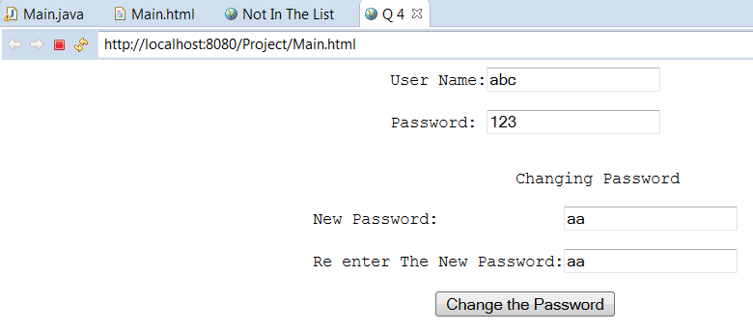

The response would be:

Example 2: The new password and reentered password are not the same:

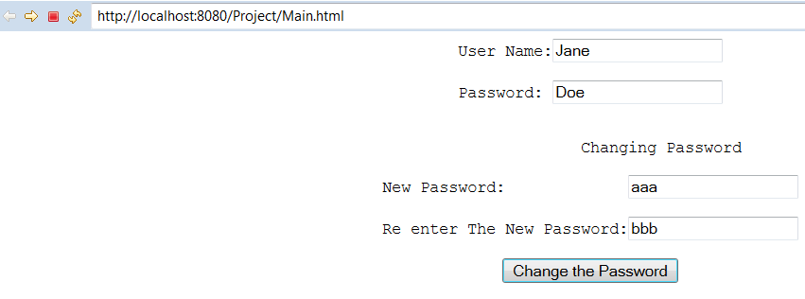
The response would be:

Example 3: The user name and password has a cookie and want to change the password:

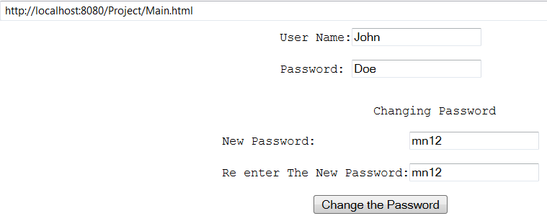

The response would be:

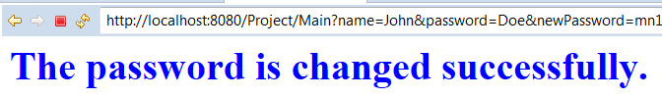

Answer
Only copy the class: Main.java

